Game Concept & Design Document

**Version 1**

Dauntlet

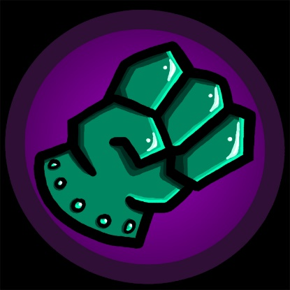

Crystal Methods

Braun, Eric

Hart, Adam

Keller, Colton

Leatherman, Garrett

Losinski, Tyler

Submission: Monday, February 23

Game Concept & Design Document Template

**Document Contents**

1 Template Introduction 1

2 Concept Document 2

2.1 Title Page 2

2.2 Introduction 3

2.3 Game Analysis 3

2.4 Game Atmosphere 5

2.5 Game Play 5

2.6 Key Features 6

2.7 Selling Features 6

3 Design Document 7

3.1 Design Guidelines 7

3.2 Game Design Definitions 7

3.3 Game Matrix 7

3.4 Game Flow Chart 8

3.5 Player Elements 8

3.5.1 Player Definition 8

3.5.2 Player Properties 8

3.5.3 Player Rewards (Power-ups & Pick-ups) 9

3.5.4 User Interface (UI) 9

3.5.5 Heads up Display (HUD) 9

3.5.6 Player View 9

3.6 Antagonistic Elements 9

3.6.1 Antagonistic Definitions 10

3.6.2 Antagonistic Properties 10

3.6.3 Antagonistic List 10

3.6.4 Artificial Intelligence (AI) 10

3.7 Global Game Elements 10

3.8 The Story 10

3.8.1 The Story Copy 10

3.9 Concept Art 10

3.10 Level Design 11

3.10.1 Level Copy 11

3.11 Audio & Sound F/X 11

3.12 Game Architecture 11

3.12.1 Game Architecture Overview 12

3.12.2 Architecture Copy 12

3.12.3 How to play Copy 12

4 Technical Document 13

4.1 System Requirements 13

4.2 Visual Content 13

4.3 Audio Content 14

4.4 Programming Content 14

4.5 Code Structure 14

4.6 Concerns and Alternatives 15

4.7 Resources 15

4.8 Technical Matrix 15

5 Appendix A 16

5.1 Taxonomy 16

5.2 Genre 16

5.3 Game Elements 17

5.4 Content 17

5.5 Theme 17

5.6 Style 17

6 Appendix B 18

7 Appendix C 1

8 Appendix D 1

# Template Introduction

This document is based on the research done during an internship at Overloaded Pocket Media. The document it’s self has been updated several based on new experiences and insight into game design. In this version it is my intension to describe a broader range of game than just mobile games, as well as provide a document for fellow students and game designers to use.

This document has been created with the intention of making a clear game design document. To do this the document has been divided into 3 different documents, the game concept document, game mechanics document and game tech document. This is done with the intention of making a modular document that can be updated and split into different versions easily.

Documents created with this game design template will focus upon creation of a well devised game. What this template does not do is predict the playability of the game and define a plan for the overall game development. It is there for important to consider this is only one phase in the Game Development process. I recommend that any game design be tested with tangible means such as pencil and paper, cards, board, etc, before any major resources are allotted to it. It is also important to understand that this document will act as a starting point and can not replace hands on interactivity and game testing.

Much of the contents of the game design will be influence by factors such as the game being licensed, the type of game and the game designer himself. In the end this template is to act as a guide to concise documentation allowing the designer to give more attention to creativity.

# Concept Document

The concept document serves the purpose as a way to present a game concept.

A general overview of the game, with the idea anyone can read and understand what the game is like.

This part of the document is one that will change very little once the concept is accepted.

## Title Page

Game Name, Game Logo, Game Catch Phrase, Document Type, Document Version.

These need to be clear so that when used as a document everyone immediately recognizes it.

## 

## Introduction

Dauntlet is a top down rogue-like comedy thriller game. There is free movement, enemies, and progression in Dauntlet.

## Game Analysis

This is a general overview of the game.

|  |  |
| --- | --- |
| **Game Description** |  |
| Genre: | * The type of genre for our game will be a top down style game with rogue like game play. * Genre types*:*   + Top Down   + Rogue   + Beat-em up |
| Game Elements: | * Allow for a ghost to beat up enemies using his awesome gauntlet. * There will be progression using point you receive either at the end of each level or by killing enemies. * Enemies should drop some items that will help you better defeat them for a short period of time. * There should also be special moves such as:   + Spin attack   + Possibly a ranged attack   + Knockback |

|  |  |
| --- | --- |
| Game Content: | * Short story about ghost who finds a gauntlet * The game should be upbeat and will include some of the following aspects   + Humor   + Cartoon Graphics   + Funny story |
| Theme: | * The theme of the game can best be described as a comedy thriller. * Some of the follow points also describe the game’s theme   + Cartoon style   + Funny   + Fantasy |
| Style: | * The style of this game will be very cartoonish making the mood a little lighter.   + Cartoonish   + Happy suspense |
| Game Sequence: | * The game will have a rather shot linear story that can’t really be changed   + Linear- Storylines |
| Player: | * The game will only support one player |
| **Game Reference** |  |
| Game Taxonomy: | Dauntlet is first and foremost designed around fun gameplay mechanics and the story of the player’s character. As such, it is classified as a fictional game/narrative. Since Crystal Methods collectively came up with the story for Dauntlet, it is a fictional work. However, the narrative story of how the main character returns the discovered gauntlet is not the primary driver of the game; the gameplay is. Therefore, Dauntlet is classified first as a game and secondly as a narrative. |
| Player Immersion: | While playing Dauntlet, the player will experience tactical, narrative, and physical immersion. The tactical nature of the game comes from maneuvering around the rooms and fighting the enemies present. The player will have to choose how to defeat the enemies, between where to go in the room, which move to use, and what enemies to kill and what ones to avoid. All of this provides tactical entertainment and immersion. Also, as the player plays through the game, they will become invested in the story of the game, both in the explicit telling, and in the implicit creation that is each play through. The player will also experience physical immersion during gameplay. One of the mechanics of the game will be knockback from player attacks. This will give a sense of physical presence and power to the player, providing a deeper level of physical immersion to the player. |
| Reference: | * The rough gameplay concept came from the arcade game gauntlet, in which the player will traverse through levels while attacking enemies and finding the exit. * The inspiration for different attacks and knockback came from the 2d Legend of Zelda games, in which the player obtains new methods of attack as the game progresses and many items have a factor of knockback. * Luigi’s Mansion was the inspiration for the multiple rooms/levels in Dauntlet with differing themes throughout, as well as the tone of mild, cutesy spookiness we wish to convey in our game. |

|  |  |
| --- | --- |
| **Game Technical** |  |
| Technical From: | This will be a 2D, top-down game with sprite-based graphics. |
| View: | The view of the game will be top-down in a legend of Zelda style in which the camera will be fixated in each room and will transition to the next at the appropriate times. |
| Platform: | This game will be written in C# with Microsoft’s XNA development software suite in Visual Studio 2013. |
| Device: | This game will be designed for play on the PC. |
| **Game Sales** |  |
| Consumer Group: | This game will be geared towards people who enjoy indie games with a shorter but still fun experience. |
| Payment: | The payment for the game will depend on which platform it is released on (Steam, Origin, Independently, etc). Payment will most likely be via paypal or credit card. |
| Estimated Price: | The price of this game will be around $1-3. |
| Device Support List | This game will be supported on all machines that can run games written with XNA. If the computer supports DX10 and Shader model 2.0, it will support Dauntlet. |

## Game Atmosphere

Dauntlet is a colorful and upbeat game. There are some sound effects for enemies and the player. There are two types of characters in Dauntlet, player and enemies. Both characters have the ability to attack and take damage. Dauntlet will have multiple rooms that you may progress through by defeating enemies.

## Game Play

Opening the game, the player should be met with a simple title screen depicting the game’s logo. There will be a small prompt “Press any button to start!” that will immediately initiate the game. The game will have a single mode of play with no planned customizable options.

The game revolves around small cartoonish ghost character named Dante, who resides in a haunted mansion and acts as the game’s controllable protagonist. In a short opening presentation, he is seen perusing the courtyard of the mansion when he discovers a single humorously large gauntlet. Other ghouls and undead creatures approach Dante and threaten to take it. In self-defense, Dante equips the gauntlet and fights his way out. Now a rogue of the mansion, Dante must fight his way through the many rooms and corridors within to find out who is the true owner of this spectral weapon.

The game is played in a top-down free-roam perspective. The player controls Dante across the labyrinth of rooms within the mansion using WASD keyboard controls and the mouse on PC or an analog stick on Xbox 360. Along the way, hostile enemies like zombies, skeletons, and other spooky-scary things will appear in each room, and the player will have to engage them in combat using the Xbox ABXY buttons (PC controls are still undecided).

Dante will have four simple RPG-like stats, three of which define his ability in combat: Speed, which determines how quickly Dante can move across the map, Power, which determines the strength of his attacks, and Stamina, which determines how many hits he can take. Stamina will act as the player’s health and will decrease as Dante is attacked by enemies, and will result in a lose condition when Dante’s stamina falls to zero. Likewise, enemies have their own health that Dante must decrease to zero to defeat them. Enemy health is not shown to the player. As Dante defeats enemies, he will accrue experience points that can increase his overall Level, the fourth stat. Level itself has no direct effect on the gameplay, but with each level-up, the player will receive an arbitrary number of points that can be allocated to Dante’s combat stats. This allows the player to fine-tune and customize the play experience, as well as adds incentive to the objective of combat. As the player progresses further into the game, the enemies will become tougher to defeat and deal more damage to Dante, meaning the player must strategize Dante’s combat and work to keep his Level up to par.

The gauntlet will have a small variety of attack actions all based on the basic act of punching – a standard forward jab that can attack enemies within immediate striking distance, a long-range jab that can strike enemies in a single direction at a distance, and a spin attack that can attack all foes in a short 360-degree range at once. Dante will only have a single basic attack at the beginning of the game and acquire further abilities as the game progresses as permanent skills. There will also be temporary consumable item buffs that will appear throughout the mansion, such as items that restore lost stamina or provide defensive boosts that decrease damage taken from enemies.

The game will be a single open-roam world divided into individual fixed-perspective rooms that are represented by rooms in the mansion. Many of the paths in the mansion will be locked or otherwise inaccessible and must be unlocked through progression of the game. If Dante loses all of his stamina, the player will be returned to an arbitrary checkpoint prior to the “death” with little or no lost progress, up to an arbitrary number of “deaths”, after which the player will receive a Game Over and must start the game anew. The game is won when Dante makes it to the final room of the mansion and defeats the final boss character.

The “fun” in the game stems from the constant real-time combat with AI-controlled opponents, where the player must make decisions on how to survive the onslaught of foes while traversing the overworld looking for a way to progress. The levelling and stat allocation system makes each play of the game more distinct and allows the player a sense of agency and fine-tuned control over the combat system. The figure that ties this all together is the cartoonish fantasy that allows players to suspend their disbelief with the story and immerse themselves in the game.

## Key Features

* Multiple rooms to explore
* Real-time overhead combat
* Several enemies with varying behaviors
* Consumables and perks
* Rpg leveling to improve your player stats​

## Selling Features

* Focus on humor in any text within the game
* Cartoon style graphics
* Satisfying punch mechanics
* All custom sounds, music, and graphics

# Design Document

This document describes how game objects behave, controlled and properties they have.

This documentation is primarily concerned with the game it’s self.

This part of the document is meant to be modular. Meaning you could have several Game Mechanic documents attached to the Concept Document.

## Design Guidelines

The goal of the design for this game was to create a fun-to-play, somewhat cutesy game about a ghost who finds a mysterious gauntlet. As such, all design choices were made with the goal of increasing fun first and providing a cutesy atmosphere second.

## Game Design Definitions

Gameplay in Dauntlet consists of advancing through rooms which contain enemies and simple, Zelda-esk puzzles by using planning and the moveset available to the player. The player will win by defeating the boss(es) at the end of each level, which will allow the player to advance to the next level and unlock another move for Dante. The player loses by running out of lives (called souls), which will force the player to restart the current level. The gameplay will focus mainly on the way the player combats the enemies and bosses with the tools available, which include the moveset and environment, along with any power-ups the player may have collected. As the game progresses, more and more of the story behind the gauntlet will be revealed, either through boss encounters, narration, or cutscenes.

The menu will allow the player to choose Continue, New Game, and exit. If the player chooses continue, he or she will be able to select which level to continue from and gameplay will commence. If a player selects new game, He or she will have the option of deleting previous data or simply starting from the beginning again.

Dante, the main character, will be controlled by the keyboard and mouse. His movement will be controlled by wasd keys and his direction will be controlled by the mouse position on the screen. The player will be able to pick which moves he uses, either through the mouse wheel or by the number keys.

## Game Matrix

|  |  |  |  |  |  |
| --- | --- | --- | --- | --- | --- |
| Object | Properties |  |  |  |  |
| Unit type | Hit Points | Attack | Mass for knockback | Ranged | Movement speed |
| Basic enemies |  |  |  |  |  |
|  |  |  |  |  |  |
| Bat | 10 | 5 | 1 | No | Very fast |
| Skeleton | 50 | 15 | 20 | Yes | Fast |
| Witch | 80 | 20 | 40 | Yes | Medium |
| Armor suit | 150 | 50 | 150 | No | Very slow |
| Zombie | 50 | 30 | 30 | No | Slow |
| Ghost | 50 | 25 | 0 | No | Medium |
|  |  |  |  |  |  |
| Environment |  |  |  |  |  |
|  |  |  |  |  |  |
| Gravestone | 100 | 0 | 100 | N/A | None |
| Sunlight | 0 | 1 | 0 | No | None |
|  |  |  |  |  |  |
| Player |  |  |  |  | Attack Speed |
|  |  |  |  |  |  |
| Basic Attack |  | 30 | 50 | No | Medium |
| Spin Attack |  | 20 | 50 | No | Fast |
| Gauntlet Boomerang |  | 15 | 50 | Yes | Medium |
| Ground Pound |  | 40 | 10 | No | Slow |

## Game Flow Chart

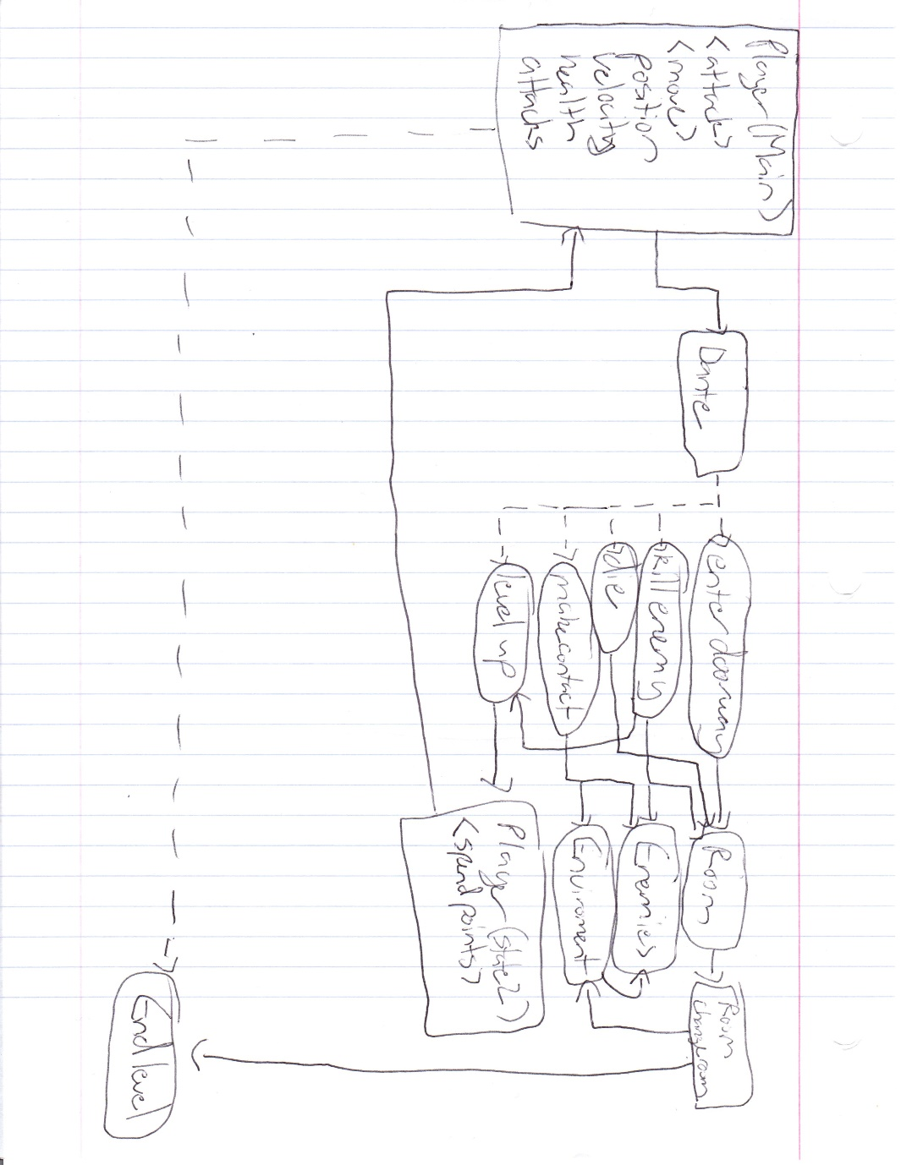

## Player Elements

The player will control a ghost called Dante, who will be referred to as Dante in the code as well. Dante will have an armored gauntlet that will be his interaction with the enemies and levels. This gauntlet will be Referred to as Fist in the code. Dante will have 4 attacks. The first will be referred to as Punch in the code and in the game. The second will be referred to as Spin in the code and in the game. The third will be known as Boomerang in the code and Fist Fling in the game. The last will be referred to as Slam in the code and Ground Pound in the game.

The player will have 3 properties: speed, power, and damage. The speed will refer to the movement speed of Dante, which in turn will increase the maximum speed of the fist. Power refers to the amount of knockback caused by the player. Increasing this increases a multiplier applied after the regular amount of momentum is calculated. For example, the players basic attack has a mass of 50. Assuming the attackspeed + movement speed was 10, the momentum of the attack would have a momentum of 500. If the power coefficient was 1.1, the new momentum would be 550, and if the player was attacking a skeleton, the skeleton would be flung back with a speed of 27.5, since its mass is 20. Damage will simply scale the attack power of each attack by a certain factor.

There will be temporary power-ups that will increase each of these stats temporarily by certain factors.

Below is the unfinished concept art for the title screen and references for the gauntlet.

### Player Definition

List of player definitions:

* Actions: The player can move freely, sprint/dash, and attack
* Information (Status): The player lives, health, and stamina will be available to the player.
* Default Properties: The player begins the game with max stamina, max health, and 5 lives.
* Winning: The player may win by beating the final boss
* Loosing: The player loses by running out of lives and health

### Player Properties

List of player definitions:

* Health – HP before you lose a life.
* Lives – how many times you may die before you lose
* Stamina – Goes down as you sprint/dash, until you stop sprinting.
* Speed – How fast the player moves, may go up and down depending on use of sprint/dash
* Power – the amount of power the player has. Has to do with damage.
* Attack – a player has 3 attacks which will all do different damage

### Player Rewards (Power-ups & Pick-ups)

Health – regenerates health by walking over object

Life – player gains one life by walking over power up

Sprint – Gives player short sprint by walking over it.

### User Interface (UI)

Some of the most important points of a UI is to get the most necessary information to the user in an obvious and necessary manner. Since our right hand input is the mouse, it would be sensible to have it responsible to interact with the majority of the UI functionalities. Main menu buttons, like New Game, Options, and Quit, will be clickable elements. However, if a controller is implemented, these selections need to compensate for that type of input. Along with the inGame pause menu, that UI will also be dominated by left-click interactivity. Each interface will be presented in a colorful and cartoonish theme, similar to how the rest of the game will look.

### Heads up Display (HUD)

Similar to the UI, the HUD will carry a similar colorful theme as the rest of the game. Simplistic cosmetics will allow the most practical information to be exemplified. Our Soul stock system will act as our upgradeable health statistic. This is one of the most important stats for the user to be consistently aware of, so making it identifiable without detracting too much focus on the game itself is key. The alignment of the same soul sprite will already be a good indicator of seasoned gamers what its functionality is. However, some text regarding its identification is always helpful for everyone, which may be implemented later on.

Here is a concept of what a HUD may look like in game. As the stock health dwindles, the flame on the left side begin to stifle until the flame is completely extinguished.



### Player View

Rooms can change drastically. The nice thing about creating room-based exploration is we don’t have to necessarily be consistent with size. Some rooms will be the same size of our camera, in which no camera movement will be applicable, while others will scale differently in height and width. In larger rooms, the camera will not begin to move until the player is farther away from the door they came from. Then, when the player reaches a threshold, the camera will move with them. In the example below, the camera would be zoomed in just enough on the player to prevent the player from seeing the opposite side of the room.

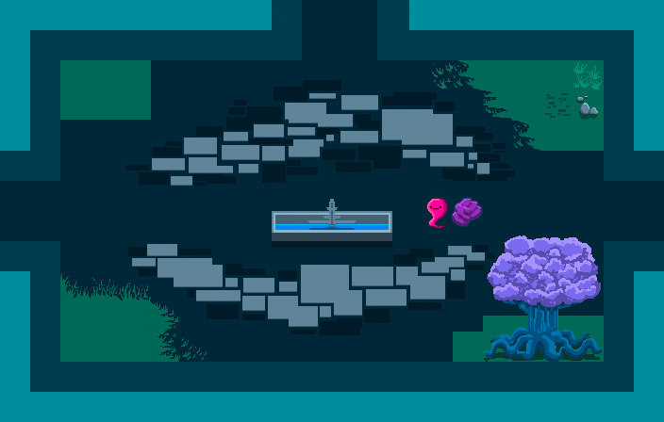

## Antagonistic Elements

Guapo (HomingBased Melee Enemy) – Nothing fancy here. Just a plain old bat. Usually comes in packs and is really easy to kill. Has a very one-track minded behavior, always attempting to attack the player.

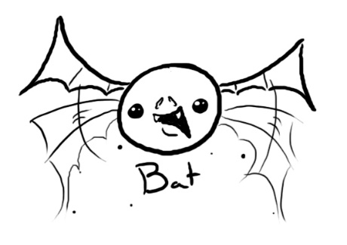

Zombie (2st Tier HomingBased Melee Enemy) – The undead that had once lived in the mansion have come back to life to seek revenge for disturbing their slumber. Similar to the bat, but they are harder to kill.

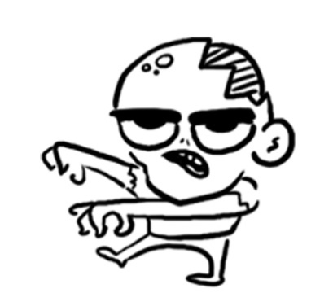

Spooky Bones (1nd Tier HomingThresholdBased Range Enemy) – A terrifying enemy and a poorly mannered skeleton. Continues to lob his own bones at you until you take him out. The first range enemy you may run into. Makes you wonder if he’ll ever run out of bones.

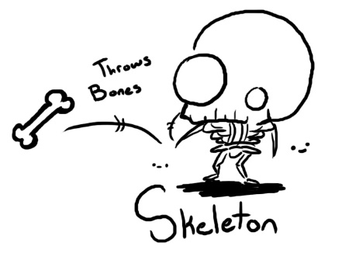

Old Crone (2nd Tier HomingThresholdBased Range Enemy) – A wandering witch that settled here due to the high spiritual energy, driven mad by her obsession with magic. There’s nothing she would like more than to capture a ghost for herself. Similar to the skeleton, but has a much more dynamic range strategy.

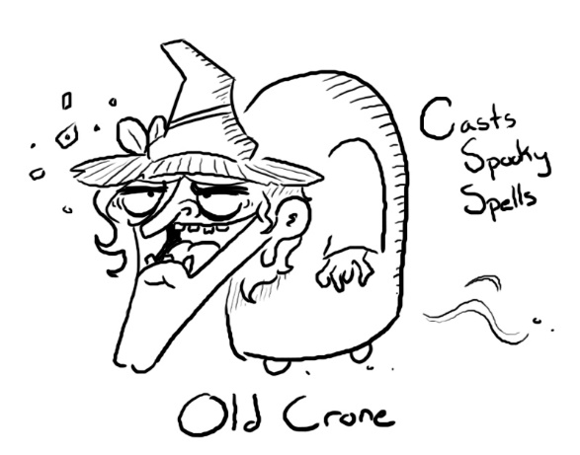

Gravestone (3rd Tier HomingBased Melee Enemy) – A cursed tombstone with affinity for smashing stuff. Accidently punching one in hopes of getting items is a sure-fire way to provoke one. Uses its head to smash its opponents.

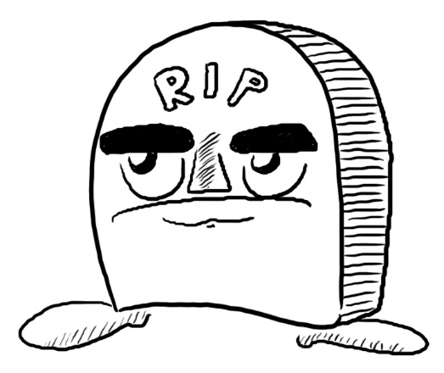

3.6.1 **Antagonistic Definitions**

Tiers imply how powerful the enemy is from lowest to highest.

HomingBased Enemy: These enemies have to make their way to the player and physically touch the player sprite before any harm is done.

HomingThesholdBased Enmey: These enemies do not require themselves to touch the player sprite before they can attack. As long as the player is within a certain radius, these types of enemies can use their attack (usually range enemies).

### Antagonistic Properties

All enemies vary under these properties:

Health

Speed

Behavior

Attack

Knockback

### Antagonistic List

-The enemy entities

-Certain destructible items

-In game puzzles

### Artificial Intelligence (AI)

As soon as a player enters a hostile room, enemies will attack depending on how close the player is to them. They will be predetermined, but once a room is clear, they don’t comeback until you restart the game. Some enemies are weaker than others, so to compensate for their lack of difficulty, more rooms will contain lower tier enemies in the beginning and a small amount of higher tier enemies. As the game progresses, this idea will flip, bringing a higher amount of high tier enemies.

Bat

Old Crone

Skeleton

Zombie

Gravestone

All AI are subject to:

-Normal State: Enemy wanders is a small radius, additional sprites may be added to show this non-detection.

-Detection State: This is where the player detection radius has been crossed and the entity starts to move towards the player.

-Attack State: The enemy continues to attack the player based on its attack type until the player or itself is dead.

-Death State: This is where the player beats the enemy and the room deletes the entity after a death animation takes place.

-If the player decides to leave during a battle or the player dies, both cases return the enemy to a Normal State

## Global Game Elements

Our game will have well defined walls that will not allow the player to pass through. There will be doors between rooms that the player can pass through. If a room is larger than the resolution, the camera will follow the player if they move off screen.

## The Story

Under a night sky where tangled brush and forest has preserved the land for years, a rotting house on a hill lays quiet. However, the silence is quickly broken by a single gauntlet that falls from the sky and crashes into the ground in a courtyard. While the small crater smolders, a small apparition named Dante floats onto the scene. Confused and intrigued by the gauntlet, the ghost wrestles it out of its resting place using its levitating powers. As soon as the gauntlet leaves the ground however, a cloud cover begins to settle in, bringing large bolts of lightning and gusts of wind. Creatures of the night begin to crawl out of the shadows, threatening the tiny ghost’s non-existence. The ghost couldn’t quite put its figurative finger on it, but it seemed like the gauntlet was cursed. Although Dante was defenseless on its own against the oncoming barrage of monsters, the gauntlet appeared to solve that issue by being the perfect kind of cursed item, the kind you can hit stuff with.

Fueled by curiosity and an underlying want to punch stuff, Dante set out to find where the gauntlet came from.

### The Story Copy

A tiny ghost finds a gauntlet and the spirits of a desolated mansion have become restless. It is up to you to bash your way through tons of enemies and make peace with the mysteries of the mansion.

## Concept Art

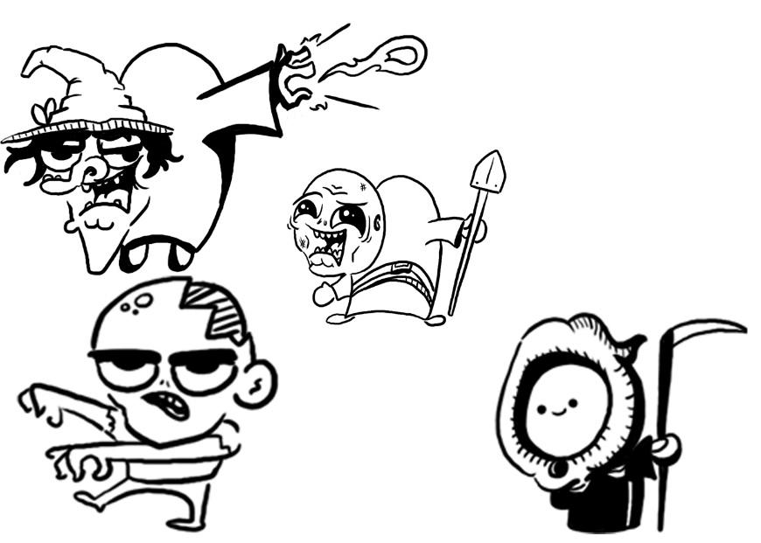

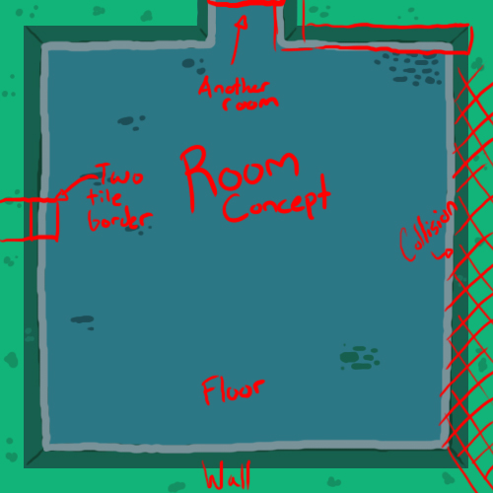

## Level Design

Here is a very basic level layout of our game.



The diamonds represent each room while the rectangles represent the levels. At the end of each level we want to have a mini boss or just a regular boss depending on if we go for multiple levels. We may have more than one level but we aren’t sure how we want it setup yet.

### Level Copy

The game will begin with a ghost finding a gauntlet and discovering he can beat up enemies with it. The enemies attack him because he has the gauntlet and after a little fighting the ghost finds out he like the power and wants the other gauntlet (because gauntlets come in pairs of two). You fight your way to the final boss and try to recover the second one.

This story is a very general way of describing the story.

## Audio & Sound F/X

All of our sound effects and music will be either found for free on the internet or will be created by our group member Garrett Leatherman.

## Game Architecture

Here is a flowchart of the different screens displayed.

### Game Architecture Overview

Our game will include two cut scenes that will include the game automatically moving the character to tell a short story. One will be at the beginning of the game where the main character finds his weapon and one at the end when the final boss is beaten. If there is any dialoged it will be displayed as text at the bottom of the screen.

When the player starts the game they will be confronted with a main menu that will include a play, options, Instructions, about, and exit buttons. The play button will start the player on the first level. The options button will allow the player to turn the music and sound FX up, down, or off. The instructions screen will show the play the basic way of playing the game. The About menu will show who made the game and where we got some of the resources. The exit button will exit the game.

The game instruction will include the following information:

* How to fight the enemies
  + The controls
  + The abilities of the player
* The end goal of the game
* How to win

### Architecture Copy

All text fro the game can be complied here.

Review Game Architecture Overview

### How to play Copy

How to play:

* Keyboard:
  + Use WASD to move around
  + Either click to attack or use space
* Controller:
  + Use the thumbsticks to move around
  + Use RB to attack
* Kill the enemies with your attack

# Technical Document

The information concerning the technical aspects of the game should be placed here.

The technical document is best achieved with consensus from the people responsible for the Visual, Programming and Audio aspects.

This part of the document is meant to be modular. Meaning you could have several Game Technical documents attached to the Concept Document and Game Mechanic Document.

## System Requirements

* Windows 7, Windows 8 or 8.1
* Shader Model 2.0 or greater
* DirectX 9.0c or greater (DirectX 10 minimum recommended)
* 2 GB RAM
* 100 MB available hard disk space

## Visual Content

* General
  + 32x32 Tile Sizes
  + 64x64 Enemies
  + .png file type
  + Best exporting quality
  + All scaling is based on camera view
* Player Elements
  + Two sprites (Ghost and Gauntlet)
  + Multidirectional Sprites
  + Stationary animation (10-11 frames)
  + Move animation (7 frames)
  + Punch animation (4 frames)
* Heads Up Display (HUD)
  + Purple stock health
  + Animated flame that dwindles as health decreases
  + Font Type: Alpha Beta BRK, 8-bit Limit
* Antagonistic Elements
  + Enemy specific stationary animation (10-11 frames)
  + Specific detection animation (5-6 frames)
  + Movement animation(varying frames)
  + Specific Hurt animation (3 frames)
  + Specific Death animation (Followed by default death smoke effect)
  + Specific Attack animation (varying frames)
* Global Elements
  + Black backdrop
  + 32x32 tiles
  + Floor tiles, wall tiles, and side-of-wall tiles

## Audio Content

* General
  + File Size Restrictions
    - Smaller than 15MB
  + File Format Type
    - .WMA
  + File Quality Type
    - 32 bit
* Player Elements
  + Type of Sound f/x
    - Hurting Enemies
    - Fist swing
    - Player hurt
    - Enemy hurt
    - Special attack noises
* Global Elements
  + Background Music
    - No Combat
    - Combat
    - Menus
* Menus
  + Type of Sound f/x
    - Noise when starting a new game

## Programming Content

* General
  + .cs, .csv, .exe filetype
  + Code will be written using standard ReSharper naming and structure conventions.
  + Game will be written and compiled in English
  + C# compatibility required to run XNA on Windows and Xbox360 platforms
  + Designed to run on 4:3 resolution televisions and computer monitors at 1024x786 px
* Player Elements
  + Combat stats (Speed, Power, Stamina, Level)
  + Combat abilities
* Antagonistic Elements
  + Type of enemy
  + AI behavior
* Global Elements
  + Current room
* Menus
  + Main Menu
    - Start Game
  + Pause Menu
    - Continue
    - Save & Quit
    - Quit

## Code Structure

This is where an overview of how objects/functions/data interact, a list of what specified functions/routines do and a list of what order modules will be written.

## Concerns and Alternatives

The main concern is not having enough time in the project to implement all of the planned details. We have stripped the project of all items deemed to be extraneous and designed the core game to still be playable in its entirety without these extra items, but still allowing room for these items to be added later in the cycle as time allows. This requires most of the code to be written abstractly, so that modules and added content can be injected into the game with little extra effort.

## Resources

Programming:

* Microsoft Visual Studio 2013
* ReSharper plugin for Visual Studio
* XNA 4.0 Refresh framework
* Farseer Physics Engine

Visual Assets:

* GNU Image Manipulation Program (GIMP) for Windows
* Inkscape
* Adobe Photoshop

Audio Assets:

* FL Studio

## Technical Matrix

|  |  |  |
| --- | --- | --- |
| Audio | Visual | Programming |
| MainTheme.wma NoCombat.wma  SkeletonSwing.wma  Swish_1.wav  Hurt.wav  Hop.wav | Dauntlet.jpg fist.png  tileset.png | Program.csDauntlet.cs GameScreen.cs  MainMenuScreen.cs  LoadingScreen.cs  GameplayScreen.cs  PauseScreen.cs  SoundManager.cs  CameraManager.cs  TileEngine.cs  PlayerEntity.cs |

# Appendix A

In this appendix there are lists for a games Taxonomy, Genre, Elements, Contents, Theme and Style. These lists are far from complete but are useful for further examples.

## Taxonomy

* Simulation
  + Story
  + Play
  + Chance
    - Fiction
    - Non Fiction
* Story
  + Simulation
  + Play
  + Chance
    - Fiction
    - Non Fiction
* Play
  + Story
  + Chance
  + Simulation
    - Fiction
    - Non Fiction

## Genre

* Basic
  + Adventure
  + Arcade (any "twitch" element)
  + Construction & Management
  + Puzzle
  + Role-play
  + Simulator
  + Strategy
* More Specific
  + Abstract (i.e., Arkanoid)
  + Adventure
  + Arcade (very generalized category)
  + Beat-em-up
  + Flight Sim/Space Sim
  + FPS (first-person shooter)
  + MMOG(Massive Multi-player Online)
    - MMORPG (role playing game)
    - MMORTS (real time strategy)
    - MMOTBS (turn base strategy)
  + Platform
  + Puzzle
  + Racing
  + RPG (role-playing game)
  + RTS (real-time strategy)
  + Shoot-em-up (scrolling shooter)
  + TBS (turn based strategy)
  + Trading

## Game Elements

* Alignment
* Catch
* Chase
* Collecting
* Combat
* Cooperation
* Dodging
* Escape
* Fighting
* Forbidden Act
* Hiding
* Jump
* Luck
* Maze
* Nursing
* Obstacles
* Puzzle
* React
* Resource Management
* Seeking
* Shooting
* Story Comprehension
* Target
* Trading
* Trivia
* Timing

## Content

* Action
* Drama
* Erotic
* Horror
* Humor
* Pure Play
* Realism
* Thriller

## Theme

* Abstract
* Crime
* Fantasy
* Noir
* Porn
* Sci-Fi
* Spy
* War
* Western

## Style

* Abstract
* Cartoon
* Manga
* Old School
* Realism

|  |  |  |  |  |  |  |  |  |  |  |  |  |  |  |  |  |  |  |  |  |  |  |  |  |  |  |  |  |  |  |  |  |  |  |  |  |  |  |  |  |  |  |  |  |  |  |  |  |  |  |  |  |  |  |  |  |  |  |  |  |  |  |  |  |  |  |
| --- | --- | --- | --- | --- | --- | --- | --- | --- | --- | --- | --- | --- | --- | --- | --- | --- | --- | --- | --- | --- | --- | --- | --- | --- | --- | --- | --- | --- | --- | --- | --- | --- | --- | --- | --- | --- | --- | --- | --- | --- | --- | --- | --- | --- | --- | --- | --- | --- | --- | --- | --- | --- | --- | --- | --- | --- | --- | --- | --- | --- | --- | --- | --- | --- | --- | --- |
| Appendix B  |  |  |  |  |  | | --- | --- | --- | --- | --- | | **Object** | **Properties** | |  |  | | *Unit type* | *Hit Points* | *Damage* | *Bullet speed* | *Movement* | | *Basic Enemies* |  |  |  |  | | Cannon -01 | 30 | 100 | Medium | NA | | Cannon -02 | 60 | 150 | Slow | NA | | Static rocket launcher | 70 | 700 | Medium | NA | | Flock 1 | 15 | 500 | NA | Medium | | Flock 2 | 15 | 35 | Slow | Medium | | Medium 1 | 80 | 350 | Fast | Slow | | Medium 2 | 90 | 400 | Medium | Slow | | Rail | 120 | 600 | NA | Slow | | Small 1 | 25 | 200 | Fast | Fast | | Small 2 | 30 | 210 | Fast | Fast | |  |

|  |
| --- |
| Appendix C image004 image003 |

# Appendix D

